**What is .pyc file and Use?**

**.pyc file contains BYTE code.**

What is BYTE code?

Byte code is an intermediate code between the source code and machine code.

It is a platform independent and efficient which is easily to read by machine

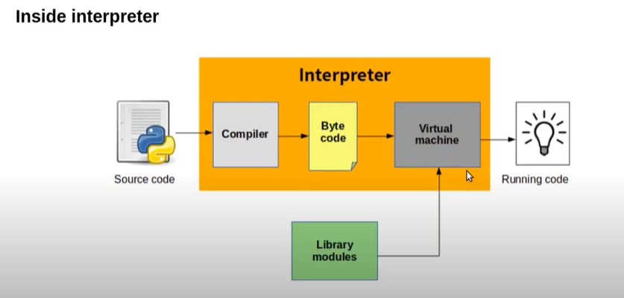

Use of BYTE code?

**By creating .pyc file no need to craete byte code for every execution.**